PYHTHON ASSIGNMENT

Q.1 What is optimization ? Define the types of optimization.

Ans- **Optimization** is the process of finding the best solution, typically by maximizing or minimizing an objective function, within a set of constraints.

Types of Optimization

1. **Linear Optimization**: Objective function and constraints are linear.

2. **Nonlinear Optimization**: Objective function or constraints are nonlinear.

3. **Integer Optimization**: Variables are restricted to integer values.

4. **Combinatorial Optimization**: Involves finding the best combination in a discrete solution space.

Q.2 Minimize the function for the code f(x,y)=x^2+y^2+3x+4y+5.

Ans-

Source Code:-

import sympy as sp

x,y=sp.symbols('x y')

print("Given Function f(x,y) is:- f=x**2+y**2+3*x+4*y+5 ")

f=x**2+y**2+3*x+4*y+5

print("Derivative w.r.t x: ")

dfdx=sp.diff(f, x)

print(dfdx)

print("Derivative w.r.t y: ")

dfdy=sp.diff(f, y)

print(dfdy)

val = sp.solve([dfdx, dfdy], [x, y])

x_val = val[x].evalf()

y_val = val[y].evalf()

val1= [x_val, y_val]

print("Minimum found at (x,y):- ",val1)

min_f=f.subs({x: x_val,y: y_val})

print("Minimum value of the function is:-",min_f)

Output:-

Given Function f(x,y) is:- f=x**2+y**2+3*x+4*y+5

Derivative w.r.t x:

2*x + 3

Derivative w.r.t y:

2*y + 4

Minimum found at (x,y):- [-1.50000000000000, -2.00000000000000]

Minimum value of the function is:- -1.25000000000000

Code Snippet:-

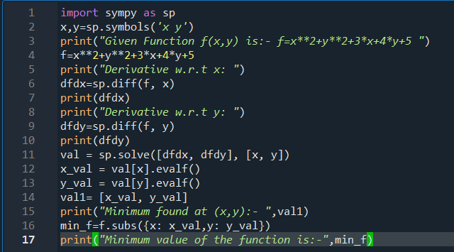

Output:-

